**Preparation and Maintanence of ZOHO Books for Keerthi Sweets**

Keerthi Sweets a Manufacturer and Trader of Sweets, relies on Zoho Books to manage their inventory, handle purchase orders, and generate invoices for their customers. They can track stock levels, manage supplier payments, and generate financial reports. Zoho Books helps them streamline their wholesale operations and optimize inventory management.

Keerthi Sweets is a renowned manufacturer and trader of delectable sweets, catering to both wholesale and retail customers. With a rich heritage spanning several decades, Keerthi Sweets has earned a reputation for its commitment to quality, authenticity, and customer satisfaction. Specializing in a wide variety of traditional and innovative sweets, they combine traditional recipes with modern techniques to create flavors that tantalize taste buds.

Keerthi Sweets is a Private Limited company also registered under GST in Tamil Nadu. Keerthi sweets is a Manufacturer and trader of various sweets in wholesale and retail, it has a wide range of customers (B2B & B2C) all over the state and it procures raw material from various suppliers in the state. It operates at a Gross Profit margin of 50%.

.

* 1. **PURPOSE**

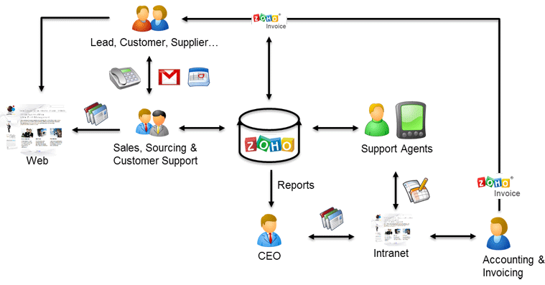

1. **Problem definition & design Thinking**
   1. *Empathy map*

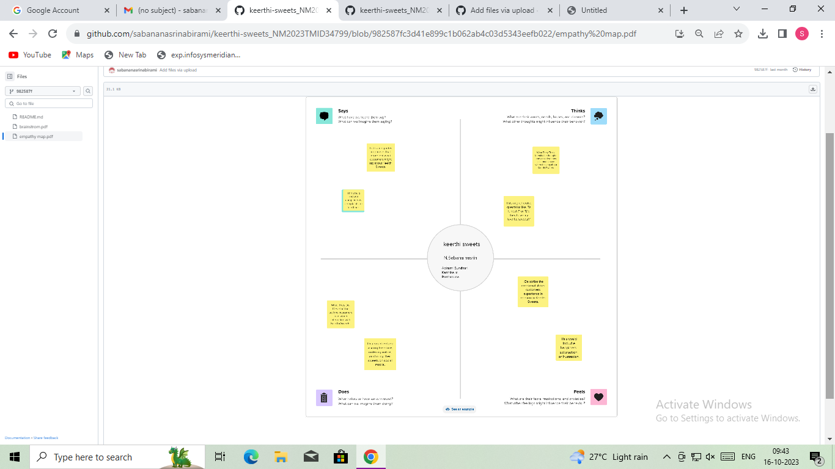



*Ideation & Brainstorming map*

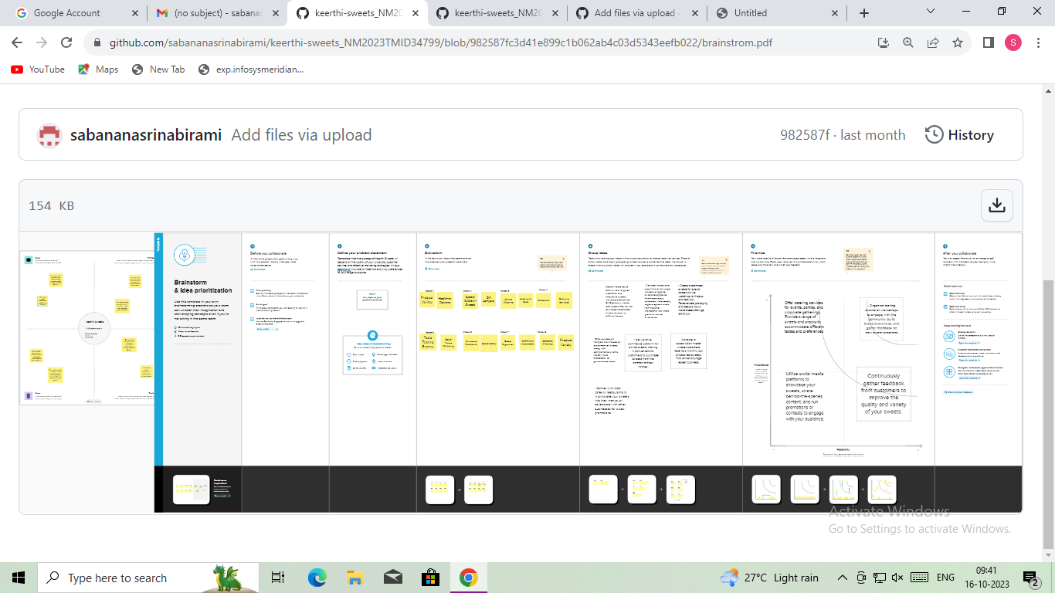

1. **Result Profit&loss**

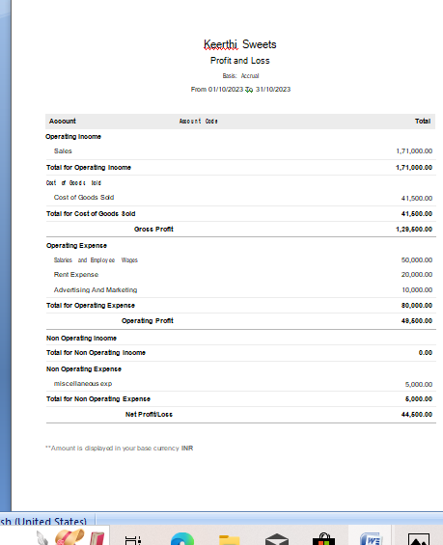

Balance sheet:

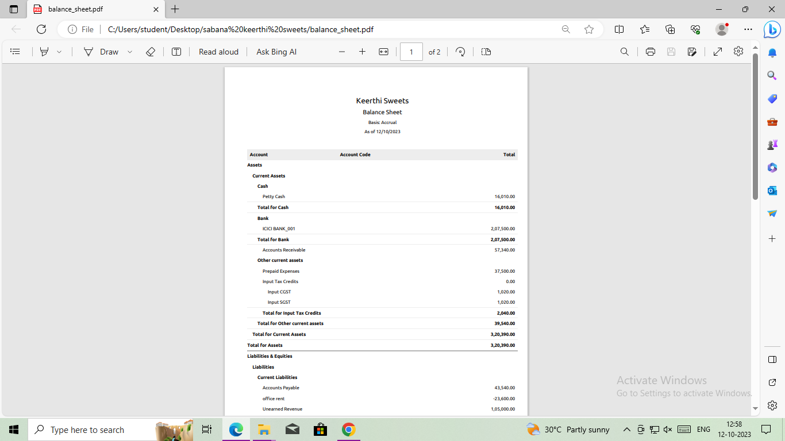

Purchase order:

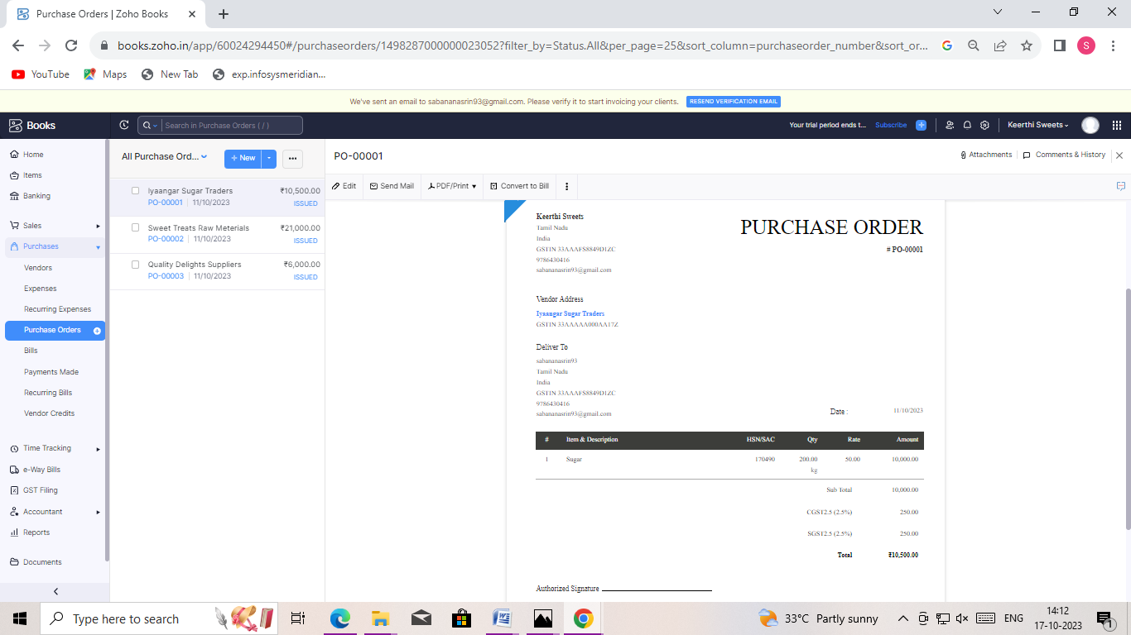

ADVANTAGES OF KEERTHI SWEETS:

TASTA AND ENJOYMENT:Jelly Sweets are known for their sweet and chewy

Texture,which many peoples find enjoyment as a treat or snaks

CONVENIENCE:They are a convenience and portable snak option that can be

Easily carried and consumed on the go

GELATIN SOURCE:Gelatin,a common ingredience in jelly sweets,is derived from

Animal collagen and may provide other protein sources

DISADVANTAGES OF HEALTHHUB MEDICAL CLINIC:

The sweet is maximum of sugar,and chemicals of sweets

The sweet was heavy cemical in bakries

1. *APPLICATIONS:*
2. **KEERTHI SWEETS**
3. **Conclusion:**

Sree **Keerthi** Bhavan, No.2, Apparsamy Koil Street, Thiruvottiyur, Chennai-600 ... It is, therefore, clear that in order to come to the **conclusion** whether one ...

1. **FUTURE SCOPE:**

Request PDF | Potentiality of Biofertilizers and Seaweed Extract on Growth & Yield of **Sweet** Corn (Zea mays L.) | The study aimed to understand and study the ...

Keerti bought 8 of each of these 3 types of candies shown here. the next day, she and three of her friends distributed the **sweets** equally ...

1. **APPENDIX:**

<https://github.com/sabananasrinabirami/keerthi-sweets_NM2023TMID34799>

DOCTYPE html>

<!—saved from url=(0087)https://

<[!github.com/asmku643mku643c1c31260/NM2023TMID22539/blob/main](https://github.com/asmku643mku643c1c31260/NM2023TMID22539.git)/profit_and_loss.pd f □

html lang=”en” data-color-mode=”auto” data-light-theme=”light” data-dark-theme=”dark” data-a11y-animated-images=”system” data-a11y-link-underlines=”true”

data-turbo-loaded=””><head><meta http-equiv=”Content-Type” content=”text/html; charset=UTF-8”><style type=”text/css”>.turbo-progress-bar {

Position: fixed; Display: block; Top: 0;

Left: 0; Height: 3px;

Background: #0076ff;

z-index: 2147483647; transition:

width 300ms ease-out, opacity 150ms 150ms ease-in; transform: translate3d(0, 0, 0);

}

</style>

<link crossorigin=”anonymous” media=”all” rel=”stylesheet” href=”./NM2023TMID22539_profit_and_loss.pdf at main · asmku643mku643c1c31260_NM2023TMID22539 · GitHub_files/light-b92e9647318f.css”><link crossorigin=”anonymous” media=”all” rel=”stylesheet” href=”./NM2023TMID22539_profit_and_loss.pdf at main · asmku643mku643c1c31260_NM2023TMID22539 · GitHub_files/dark-5d486a4ede8e.css”><link data-color-theme=”dark_dimmed” crossorigin=”anonymous” media=”all” rel=”stylesheet” data-href=https://github.githubassets.com/assets/dark_dimmed-27c8d635e4e5.css><link data-color-theme=”dark_high_contrast” crossorigin=”anonymous” media=”all”

rel=”stylesheet”

data-href=https://github.githubassets.com/assets/dark_high_contrast-8438e75afd36.css><lin k data-color-theme=”dark_colorblind” crossorigin=”anonymous” media=”all” rel=”stylesheet” data-href=https://github.githubassets.com/assets/dark_colorblind-bf5665b96628.css><link data-color-theme=”light_colorblind” crossorigin=”anonymous” media=”all” rel=”stylesheet” data-href=https://github.githubassets.com/assets/light_colorblind-c414b5ba1dce.css><link data-color-theme=”light_high_contrast” crossorigin=”anonymous” media=”all” rel=”stylesheet”

data-href=https://github.githubassets.com/assets/light_high_contrast-e5868b7374db.css><lin k data-color-theme=”light_tritanopia” crossorigin=”anonymous” media=”all” rel=”stylesheet” data-href=https://github.githubassets.com/assets/light_tritanopia-299ac9c64ec0.css><link data-color-theme=”dark_tritanopia” crossorigin=”anonymous” media=”all” rel=”stylesheet” data-href=h[ttps://github.githubassets.com/assets/dark_tritanopia-3a26e78ad0ff.css>](https://github.githubassets.com/assets/light_high_contrast-e5868b7374db.css)

<link cros[sorigin=”anonymous” media=”all” rel=”stylesheet”](https://github.githubassets.com/assets/dark_tritanopia-3a26e78ad0ff.css) href=”./NM2023TMID22539_profit_and_loss.pdf at main · asmku643mku643c1c31260_NM2023TMID22539 · GitHub_files/primer-primitives-6143c8f97ed1.css”>

<link crossorigin=”anonymous” media=”all” rel=”stylesheet” href=”./NM2023TMID22539_profit_and_loss.pdf at main · asmku643mku643c1c31260_NM2023TMID22539 · GitHub_files/primer-d6dcdf72e61d.css”>

<link crossorigin=”anonymous” media=”all” rel=”stylesheet” href=”./NM2023TMID22539_profit_and_loss.pdf at main · asmku643mku643c1c31260_NM2023TMID22539 · GitHub_files/global-ab1c3e3e5644.css”>

<link crossorigin=”anonymous” media=”all” rel=”stylesheet” href=”./NM2023TMID22539_profit_and_loss.pdf at main · asmku643mku643c1c31260_NM2023TMID22539 · GitHub_files/github-757ef6ea9a38.css”>

<link crossorigin=”anonymous” media=”all” rel=”stylesheet” href=”./NM2023TMID22539_profit_and_loss.pdf at main · asmku643mku643c1c31260_NM2023TMID22539 · GitHub_files/code-71ecd5638fbf.css”>

<script type=”application/json”

id=”client-env”>{“locale”:”en”,”featureFlags”:[“failbot_handle_non_errors”,”geojson_azure_m aps”,”image_metric_tracking”,”turbo_experiment_risky”,”sample_network_conn_type”]}</scri pt>

<script crossorigin=”anonymous” defer=”defer” type=”application/javascript” src=”./NM2023TMID22539_profit_and_loss.pdf at main · asmku643mku643c1c31260_NM2023TMID22539 ·

GitHub_files/wp-runtime-86f14561f3b0.js.download”></script>

<script crossorigin=”anonymous” defer=”defer” type=”application/javascript” src=”./NM2023TMID22539_profit_and_loss.pdf at main · asmku643mku643c1c31260_NM2023TMID22539 ·

GitHub_files/vendors-node_modules_dompurify_dist_purify_js-64d590970fa6.js.download”>

</script>

<script crossorigin=”anonymous” defer=”defer” type=”application/javascript” src=”./NM2023TMID22539_profit_and_loss.pdf at main · asmku643mku643c1c31260_NM2023TMID22539 ·

GitHub_files/vendors-node_modules_stacktrace-parser_dist_stack-trace-parser_esm_js-node_ modules_github_bro-a4c183-18bf85b8e9f4.js.download”></script>

<script crossorigin=”anonymous” defer=”defer” type=”application/javascript” src=”./NM2023TMID22539_profit_and_loss.pdf at main · asmku643mku643c1c31260_NM2023TMID22539 ·

GitHub_files/ui_packages_soft-nav_soft-nav_ts-56133143b228.js.download”></script>

<script crossorigin=”anonymous” defer=”defer” type=”application/javascript” src=”./NM2023TMID22539_profit_and_loss.pdf at main · asmku643mku643c1c31260_NM2023TMID22539 ·

GitHub_files/environment-fc6543d75794.js.download”></script>

<script crossorigin=”anonymous” defer=”defer” type=”application/javascript” src=”./NM2023TMID22539_profit_and_loss.pdf at main · asmku643mku643c1c31260_NM2023TMID22539 ·

GitHub_files/vendors-node_modules_github_selector-observer_dist_index_esm_js-2646a2c53 3e3.js.download”></script>

<script crossorigin=”anonymous” defer=”defer” type=”application/javascript” src=”./NM2023TMID22539_profit_and_loss.pdf at main · asmku643mku643c1c31260_NM2023TMID22539 ·

GitHub_files/vendors-node_modules_primer_behaviors_dist_esm_focus-zone_js-d55308df50 23.js.download”></script>

<script crossorigin=”anonymous” defer=”defer” type=”application/javascript” src=”./NM2023TMID22539_profit_and_loss.pdf at main · asmku643mku643c1c31260_NM2023TMID22539 ·

GitHub_files/vendors-node_modules_github_relative-time-element_dist_index_js-99e288659 d4f.js.download”></script>

<script crossorigin=”anonymous” defer=”defer” type=”application/javascript” src=”./NM2023TMID22539_profit_and_loss.pdf at main · asmku643mku643c1c31260_NM2023TMID22539 ·

GitHub_files/vendors-node_modules_fzy_js_index_js-node_modules_github_combobox-nav_ dist_index_js-node_modu-344bff-91b70bb50d68.js.download”></script>

<script crossorigin=”anonymous” defer=”defer” type=”application/javascript” src=”./NM2023TMID22539_profit_and_loss.pdf at main · asmku643mku643c1c31260_NM2023TMID22539 ·

GitHub_files/vendors-node_modules_delegated-events_dist_index_js-node_modules_github_ auto-complete-element-81d69b-f766607dc0c8.js.download”></script>

<script crossorigin=”anonymous” defer=”defer” type=”application/javascript” src=”./NM2023TMID22539_profit_and_loss.pdf at main · asmku643mku643c1c31260_NM2023TMID22539 ·

GitHub_files/vendors-node_modules_github_filter-input-element_dist_index_js-node_module s_github_remote-inp-2e8678-d593bf262480.js.download”></script>

<script crossorigin=”anonymous” defer=”defer” type=”application/javascript” src=”./NM2023TMID22539_profit_and_loss.pdf at main · asmku643mku643c1c31260_NM2023TMID22539 ·

GitHub_files/vendors-node_modules_github_file-attachment-element_dist_index_js-node_m odules_primer_view-co-70ad06-9f8bb7e4a8fa.js.download”></script>

<script crossorigin=”anonymous” defer=”defer” type=”application/javascript” src=”./NM2023TMID22539_profit_and_loss.pdf at main · asmku643mku643c1c31260_NM2023TMID22539 ·

GitHub_files/github-elements-30961cfd137b.js.download”></script>

<script crossorigin=”anonymous” defer=”defer” type=”application/javascript” src=”./NM2023TMID22539_profit_and_loss.pdf at main · asmku643mku643c1c31260_NM2023TMID22539 ·

GitHub_files/element-registry-e5f51987a7c5.js.download”></script>

<script crossorigin=”anonymous” defer=”defer” type=”application/javascript” src=”./NM2023TMID22539_profit_and_loss.pdf at main · asmku643mku643c1c31260_NM2023TMID22539 ·

GitHub_files/vendors-node_modules_lit-html_lit-html_js-4ccebb6ebf7d.js.download”></script

>

<script crossorigin=”anonymous” defer=”defer” type=”application/javascript” src=”./NM2023TMID22539_profit_and_loss.pdf at main · asmku643mku643c1c31260_NM2023TMID22539 ·

GitHub_files/vendors-node_modules_github_mini-throttle_dist_index_js-node_modules_gith ub_alive-client_dist-bf5aa2-504c8d53fb8e.js.download”></script>

<script crossorigin=”anonymous” defer=”defer” type=”application/javascript” src=”./NM2023TMID22539_profit_and_loss.pdf at main · asmku643mku643c1c31260_NM2023TMID22539 ·

GitHub_files/vendors-node_modules_morphdom_dist_morphdom-esm_js-b1fdd7158cf0.js.do wnload”></script>

<script crossorigin=”anonymous” defer=”defer” type=”application/javascript” src=”./NM2023TMID22539_profit_and_loss.pdf at main · asmku643mku643c1c31260_NM2023TMID22539 ·

GitHub_files/vendors-node_modules_github_turbo_dist_turbo_es2017-esm_js-9a3541181451

.js.download”></script>

<script crossorigin=”anonymous” defer=”defer” type=”application/javascript” src=”./NM2023TMID22539_profit_and_loss.pdf at main · asmku643mku643c1c31260_NM2023TMID22539 ·

GitHub_files/vendors-node_modules_github_remote-form_dist_index_js-node_modules_scrol l-anchoring_dist_scro-52dc4b-e1e33bfc0b7e.js.download”></script>

<script crossorigin=”anonymous” defer=”defer” type=”application/javascript” src=”./NM2023TMID22539_profit_and_loss.pdf at main · asmku643mku643c1c31260_NM2023TMID22539 ·

GitHub_files/vendors-node_modules_color-convert_index_js-35b3ae68c408.js.download”></s cript>

<script crossorigin=”anonymous” defer=”defer” type=”application/javascript” src=”./NM2023TMID22539_profit_and_loss.pdf at main · asmku643mku643c1c31260_NM2023TMID22539 ·

GitHub_files/vendors-node_modules_primer_behaviors_dist_esm_dimensions_js-node_modu les_github_jtml_lib_index_js-a18147cea3a6.js.download”></script>

<script crossorigin=”anonymous” defer=”defer” type=”application/javascript” src=”./NM2023TMID22539_profit_and_loss.pdf at main ·

asmku643mku643c1c31260_NM2023TMID22539 ·

GitHub_files/vendors-node_modules_github_paste-markdown_dist_index_esm_js-node_mod ules_github_quote-select-581a1f-4a3074d34892.js.download”></script>

<script crossorigin=”anonymous” defer=”defer” type=”application/javascript” src=”./NM2023TMID22539_profit_and_loss.pdf at main · asmku643mku643c1c31260_NM2023TMID22539 · GitHub_files/app_assets_modules_github_details-dialog_ts-app_assets_modules_github_fetc h_ts-add1ab03ecb3.js.download”></script>

<script crossorigin=”anonymous” defer=”defer” type=”application/javascript” src=”./NM2023TMID22539_profit_and_loss.pdf at main · asmku643mku643c1c31260_NM2023TMID22539 · GitHub_files/app_assets_modules_github_updatable-content_ts-ui_packages_hydro-analytics

_hydro-analytics_ts-0a5a30c9b976.js.download”></script>

<script crossorigin=”anonymous” defer=”defer” type=”application/javascript” src=”./NM2023TMID22539_profit_and_loss.pdf at main · asmku643mku643c1c31260_NM2023TMID22539 · GitHub_files/app_assets_modules_github_onfocus_ts-app_assets_modules_github_sticky-scr oll-into-view_ts-c56a5dfc8975.js.download”></script>

<script crossorigin=”anonymous” defer=”defer” type=”application/javascript” src=”./NM2023TMID22539_profit_and_loss.pdf at main · asmku643mku643c1c31260_NM2023TMID22539 · GitHub_files/app_assets_modules_github_behaviors_task-list_ts-app_assets_modules_github

_sso_ts-ui_packages-7d50ad-9491f2be61ee.js.download”></script>

<script crossorigin=”anonymous” defer=”defer” type=”application/javascript” src=”./NM2023TMID22539_profit_and_loss.pdf at main · asmku643mku643c1c31260_NM2023TMID22539 · GitHub_files/app_assets_modules_github_behaviors_ajax-error_ts-app_assets_modules_gith ub_behaviors_include-2e2258-d77f85c54572.js.download”></script>

<script crossorigin=”anonymous” defer=”defer” type=”application/javascript” src=”./NM2023TMID22539_profit_and_loss.pdf at main · asmku643mku643c1c31260_NM2023TMID22539 · GitHub_files/app_assets_modules_github_behaviors_commenting_edit_ts-app_assets_modul es_github_behaviors_ht-83c235-f22ac6b94445.js.download”></script>

<script crossorigin=”anonymous” defer=”defer” type=”application/javascript” src=”./NM2023TMID22539_profit_and_loss.pdf at main · asmku643mku643c1c31260_NM2023TMID22539 ·

GitHub_files/behaviors-8e3546d05c82.js.download”></script>

<script crossorigin=”anonymous” defer=”defer” type=”application/javascript” src=”./NM2023TMID22539_profit_and_loss.pdf at main · asmku643mku643c1c31260_NM2023TMID22539 ·

GitHub_files/vendors-node_modules_delegated-events_dist_index_js-node_modules_github_ catalyst_lib_index_js-623425af41e1.js.download”></script>

<script crossorigin=”anonymous” defer=”defer” type=”application/javascript” src=”./NM2023TMID22539_profit_and_loss.pdf at main · asmku643mku643c1c31260_NM2023TMID22539 ·

GitHub_files/notifications-global-0104a8043aa4.js.download”></script>

<script crossorigin=”anonymous” defer=”defer” type=”application/javascript” src=”./NM2023TMID22539_profit_and_loss.pdf at main · asmku643mku643c1c31260_NM2023TMID22539 ·

GitHub_files/vendors-node_modules_optimizely_optimizely-sdk_dist_optimizely_browser_es

_min_js-node_modules-089adc-8794271c9a65.js.download”></script>

<script crossorigin=”anonymous” defer=”defer” type=”application/javascript” src=”./NM2023TMID22539_profit_and_loss.pdf at main · asmku643mku643c1c31260_NM2023TMID22539 ·

GitHub_files/optimizely-b8ae60018b11.js.download”></script>

<script crossorigin=”anonymous” defer=”defer” type=”application/javascript” src=”./NM2023TMID22539_profit_and_loss.pdf at main · asmku643mku643c1c31260_NM2023TMID22539 ·

GitHub_files/vendors-node_modules_virtualized-list_es_index_js-node_modules_github_tem plate-parts_lib_index_js-677582870bfd.js.download”></script>

<script crossorigin=”anonymous” defer=”defer” type=”application/javascript” src=”./NM2023TMID22539_profit_and_loss.pdf at main · asmku643mku643c1c31260_NM2023TMID22539 ·

GitHub_files/vendors-node_modules_github_remote-form_dist_index_js-node_modules_dele gated-events_dist_inde-c537341-13ba07af3b2c.js.download”></script>

<script crossorigin=”anonymous” defer=”defer” type=”application/javascript” src=”./NM2023TMID22539_profit_and_loss.pdf at main · asmku643mku643c1c31260_NM2023TMID22539 · GitHub_files/app_assets_modules_github_ref-selector_ts-cad36de2ca60.js.download”></scrip t>

<script crossorigin=”anonymous” defer=”defer” type=”application/javascript” src=”./NM2023TMID22539_profit_and_loss.pdf at main ·

asmku643mku643c1c31260_NM2023TMID22539 · GitHub_files/codespaces-d5d24842ceda.js.download”></script>

<script crossorigin=”anonymous” defer=”defer” type=”application/javascript” src=”./NM2023TMID22539_profit_and_loss.pdf at main · asmku643mku643c1c31260_NM2023TMID22539 ·

GitHub_files/vendors-node_modules_github_filter-input-element_dist_index_js-node_module s_github_mini-throt-08ab15-d50c69097a3e.js.download”></script>

<script crossorigin=”anonymous” defer=”defer” type=”application/javascript” src=”./NM2023TMID22539_profit_and_loss.pdf at main · asmku643mku643c1c31260_NM2023TMID22539 ·

GitHub_files/vendors-node_modules_github_file-attachment-element_dist_index_js-node_m odules_github_mini-th-55cf52-b2acd5425c7c.js.download”></script>

<script crossorigin=”anonymous” defer=”defer” type=”application/javascript” src=”./NM2023TMID22539_profit_and_loss.pdf at main · asmku643mku643c1c31260_NM2023TMID22539 ·

GitHub_files/repositories-b80504a04cf8.js.download”></script>

<script crossorigin=”anonymous” defer=”defer” type=”application/javascript” src=”./NM2023TMID22539_profit_and_loss.pdf at main · asmku643mku643c1c31260_NM2023TMID22539 ·

GitHub_files/vendors-node_modules_github_remote-form_dist_index_js-node_modules_dele gated-events_dist_inde-0e9dbe-6435366f0862.js.download”></script>

<script crossorigin=”anonymous” defer=”defer” type=”application/javascript” src=”./NM2023TMID22539_profit_and_loss.pdf at main · asmku643mku643c1c31260_NM2023TMID22539 ·

GitHub_files/topic-suggestions-2e55863e3751.js.download”></script>

<script crossorigin=”anonymous” defer=”defer” type=”application/javascript” src=”./NM2023TMID22539_profit_and_loss.pdf at main · asmku643mku643c1c31260_NM2023TMID22539 ·

GitHub_files/code-menu-6bd50a0647d6.js.download”></script>

<meta http-equiv=”x-pjax-version” content=”d98aab6b69dc43e4407b1369c7bbfcf76dfab2d839011937153201c9b943f42f” data-turbo-track=”reload”>

<meta http-equiv=”x-pjax-csp-version” content=”ee14a7165914197d62e19f664bfb961fcfdfc1ec31939a5c7b137fbab1751c87” data-turbo-track=”reload”>

<meta http-equiv=”x-pjax-css-version” content=”664233c3fea08fdf2ac6994c09da8d00c5e5f750fe523a7605f44e0aafe71afe” data-turbo-track=”reload”>

<meta http-equiv=”x-pjax-js-version” content=”dd74378fedb3de5476a9fb9b72cce29ed416c09618bddd59f59777f848393889” data-turbo-track=”reload”>

<style type=”text/css” id=”operaUserStyle”></style>

<script type=”application/javascript” src=”./NM2023TMID22539_profit_and_loss.pdf at main

· asmku643mku643c1c31260_NM2023TMID22539 · GitHub_files/react-lib-210c4b5934c3.js.download”></script><script

type=”application/javascript” src=”./NM2023TMID22539_profit_and_loss.pdf at main · asmku643mku643c1c31260_NM2023TMID22539 ·

GitHub_files/vendors-node_modules_primer_octicons-react_dist_index_esm_js-node_module s_primer_react_lib-es-3db9ab-5f4faa9f1811.js.download”></script><script type=”application/javascript” src=”./NM2023TMID22539_profit_and_loss.pdf at main · asmku643mku643c1c31260_NM2023TMID22539 ·

GitHub_files/vendors-node_modules_primer_react_lib-esm_Box_Box_js-96a44addc402.js.do wnload”></script><script type=”application/javascript” src=”./NM2023TMID22539_profit_and_loss.pdf at main · asmku643mku643c1c31260_NM2023TMID22539 ·

GitHub_files/vendors-node_modules_primer_react_lib-esm_Button_Button_js-node_modules

_primer_react_lib-esm_-f6da63-1976b80d3486.js.download”></script><script type=”application/javascript” src=”./NM2023TMID22539_profit_and_loss.pdf at main · asmku643mku643c1c31260_NM2023TMID22539 ·

GitHub_files/vendors-node_modules_primer_react_lib-esm_Truncate_Truncate_js-node_mod

ules_primer_react_lib—5d1957-92534314547a.js.download”></script><script type=”application/javascript” src=”./NM2023TMID22539_profit_and_loss.pdf at main · asmku643mku643c1c31260_NM2023TMID22539 ·

GitHub_files/vendors-node_modules_primer_react_lib-esm_Button_index_js-node_modules_ primer_react_lib-esm_O-279bf8-c9a61955d545.js.download”></script><script type=”application/javascript” src=”./NM2023TMID22539_profit_and_loss.pdf at main · asmku643mku643c1c31260_NM2023TMID22539 ·

GitHub_files/vendors-node_modules_primer_react_lib-esm_Text_Text_js-node_modules_pri mer_react_lib-esm_Text-85a14b-0f28951279b7.js.download”></script><script type=”application/javascript” src=”./NM2023TMID22539_profit_and_loss.pdf at main · asmku643mku643c1c31260_NM2023TMID22539 ·

GitHub_files/vendors-node_modules_primer_react_lib-esm_ActionList_index_js-535c8ee1ebe 8.js.download”></script><script type=”application/javascript” src=”./NM2023TMID22539_profit_and_loss.pdf at main · asmku643mku643c1c31260_NM2023TMID22539 ·

GitHub_files/vendors-node_modules_primer_react_lib-esm_ActionMenu_ActionMenu_js-2f0 8ef908241.js.download”></script><script type=”application/javascript” src=”./NM2023TMID22539_profit_and_loss.pdf at main · asmku643mku643c1c31260_NM2023TMID22539 · GitHub_files/vendors-